**INEURON ASSIGNMENTS**

**Python Basics : Assignment 4**

## **Question 1:** What exactly is []

**Answer**:

* [] is an empty list

## **Question 2:** In a list of values stored in a variable called spam, how would you assign the value 'hello' as the third value? (Assume [2, 4, 6, 8, 10] are in spam.)

**Answer**:

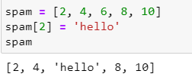

Let's pretend the spam includes the list ['a', 'b', 'c', 'd'] for the next three queries.

## **Question 3:** What is the value of spam[int(int('3' * 2) / 11)]

**Answer**:

* It will return 3rd index value from spam list. The result is ‘d’.

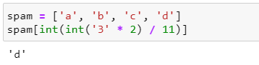

## **Question 4:** What is the value of spam[-1]

**Answer**:

* It will return last value in list. The result is ‘d’

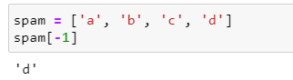

## **Question 5:** What is the value of spam[:2]

**Answer**:

* It will return 2 values from 0th index from spam list. The result is list of [‘a’, ‘b’].

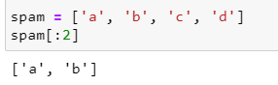

Let's pretend bacon has the list [3.14, 'cat,' 11, 'cat,' True] for the next three questions.

## **Question 6:** What is the value of bacon.index('cat')

**Answer**:

* It will return index position of value ‘cat’. The result is 1.

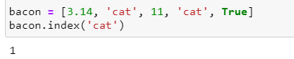

## **Question 7:** How does bacon.append(99) change the look of the list value in bacon

**Answer**:

* 99 is append to the list at last and the bacon list becomes like this [3.14, 'cat', 11, 'cat', True, 99]

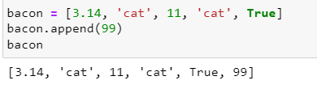

## **Question 8:** How does bacon.remove('cat') change the look of the list in bacon

**Answer**:

* It will remove first found ‘cat’ in the list.

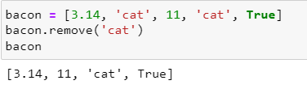

## **Question 9:** What are the list concatenation and list replication operators

**Answer**:

* List concatenation operator (+)
* List Replication operator (*)

**Question 10: What is difference between the list methods append() and insert()**

**Answer**:

* append() -> it will add values at last index position of the list
* insert() -> it will add values at specific index position of the list

**Question 11: What are the two methods for removing items from a list**

**Answer**:

* 1. remove() – To remove specific item
* 2. pop() – To remove items at specific index.

**Question 12: Describe how list values and string values are identical**

**Answer**:

* Both lists and strings can be passed to len(), have indexes and slices, be used in for loops, be concatenated or replicated, and be used with the in and not in operators

**Question 13:** **What's the difference between tuples and lists?**

**Answer**:

* List are mutable and Tuples are immutable.
* List is represent with [] and Tuples are represented with ()

**Question 14:** **How do you type a tuple value that only contains the integer 42**?

**Answer**:

* To represent single value as Tuple, we use trailing comma like (42,)

**Question 15:** **How do you get a list value's tuple form? How do you get a tuple value's list form**?

**Answer**:

* Using tuple() and list() method respectively.

**Question 16: Variables that "contain" list values are not necessarily lists themselves. Instead, what do they contain**?

**Answer**:

* They contain references to list values

**Question 17:** **How do you distinguish between copy.copy() and copy.deepcopy()**

**Answer**:

* copy.copy() will make a shallow copy of the list. It means, the changes made in original will affect the new copy also
* copy.deepcopy() will make deepcopy of the list. It means, the changes made in original will not affect the new copy.